## ***1. Download & Install VirtualBox***

- If SDK is not ready in your PC, you can see this error

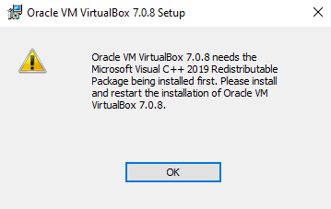

- If you meet above error, please install SDK like this.

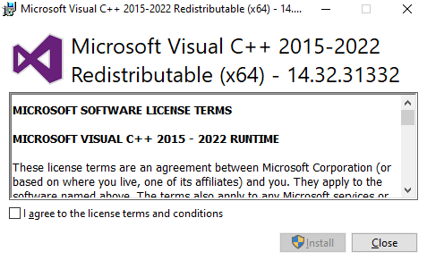

-  **After reboot, install Virtualbox** : <https://www.virtualbox.org/>

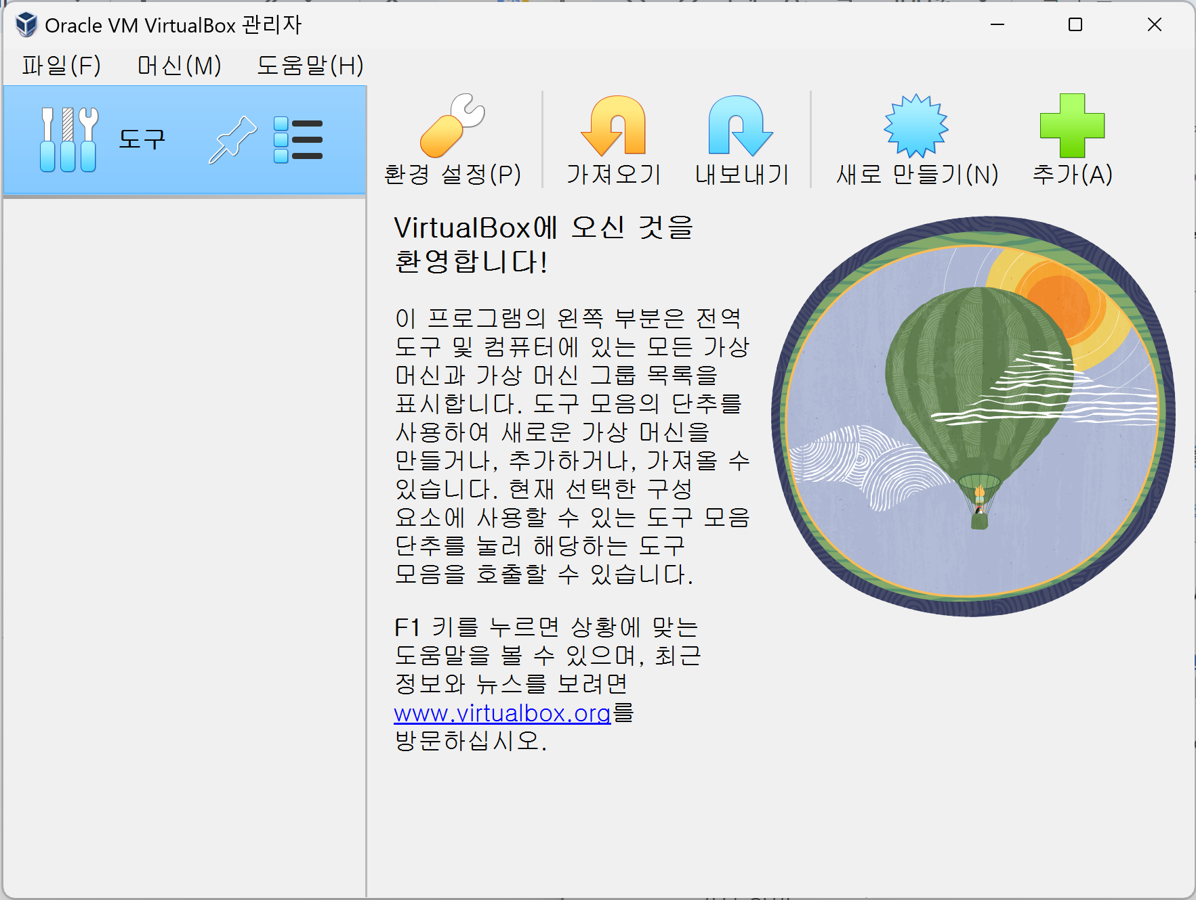

## 

## ***2. Setup VirtualBox***

### **2.1 Setup Return Key**

- To return to Windows from a VM, you have to setup a Key

- How: File - Preferences - Input - Virtual Machine - Host key - Input <Ctrl+Alt>

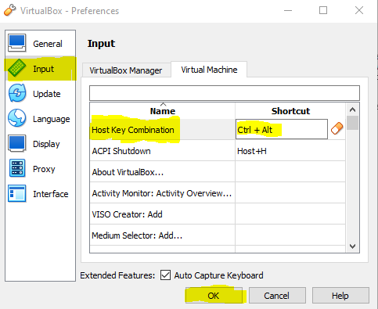

**2.2 Add NAT**

- Why: To make a local network between VMs

- How: File - Tool - Network Manager - Select <NAT Networks> tab - Create -

Input Subnet (10.0.2.0/24) - Enable DHCP

